**What is System Monitoring?**

System monitoring is a *daily routine activity* and this document provides a systematic step by step procedure for Server Monitoring. It gives an overview of technical aspects and concepts for proactive system monitoring. Few of them are:

* Checking Application Servers.
* Monitoring System-wide Work Processes.
* Monitoring Work Processes for Individual Instances.
* Monitoring Lock Entries.
* CPU Utilization
* Available Space in Database.
* Monitoring Update Processes.
* Monitoring System Log.
* Buffer Statistics

Some others are:

* Monitoring Batch Jobs
* Spool Request Monitoring.
* Number of Print Requests
* ABAP Dump Analysis.
* Database Performance Monitor.
* Database Check.
* Monitoring Application Users.

**Why Daily Basic checks / System Monitoring?**

[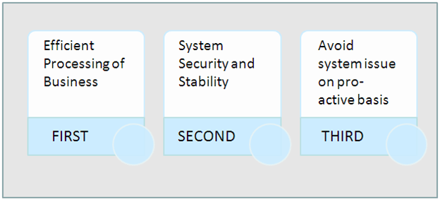](https://www.guru99.com/images/sap/2013/05/050913_0552_1.png)

**How do we do monitor a SAP System?**

**Checking Application Servers (SM51)**

This transaction is used to check all active application servers.

[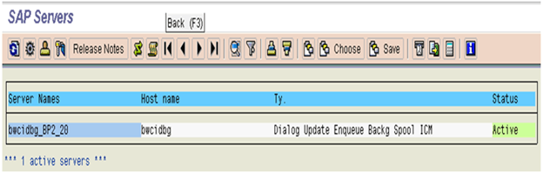](https://www.guru99.com/images/sap/2013/05/050913_0552_2.png)

Here you can see which services or work processes are configured in each instance.

This transaction code will be useful to view all the hostnames and application servers status. If any application server is down, the same can be identified using status of the server column. We can also figure out different Message types (Dialog, Batch, Update, Upd2, Spool, ICM etc) configured for the respective servers.

**Monitoring Work Processes for Individual Instances SM50:**

Displays all running, waiting, stopped and PRIV processes related to a particular instance. Under this step we check all the processes; the *process status should always be waiting or running*. If any process is having a status other than waiting or running we need to check that particular process and report accordingly.

[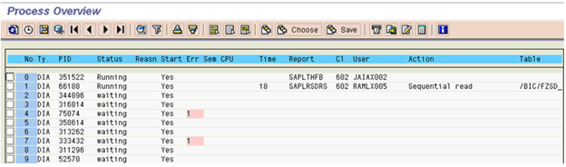](https://www.guru99.com/images/sap/2013/05/050913_0552_3.png)

This transaction displays a lot of information like:

1. Status of Work process (whether it's occupied or not)
2. If the work process is running, you may be able to see the action taken by it in the Action column.
3. You can which table is being worked upon

Some of the typical problems:

* The user takes a long time to log on/not able to logon/online transaction very slow. This could be the result of the DIA work processes are fully utilized. There could be also the result of long running jobs (red indicator under the Time column). If necessary you can cancel the session by selecting the jobs then go to Process>Cancel Without core. This will cancel the job and release the work process for other user/process
* Some users may have PRIV status under **Reason** column. This could be that the user transaction is so big that it requires more memory. When this happen the DIA work process will be 'owned' by the user and will not let other users use. If this happens, check with the user and if possible run the job as a background job.
* If there is a long print job on SPO work process, investigate the problem. It could be a problem related to the print server or printer.

**Monitoring System-wide Work Processes (SM66)**

[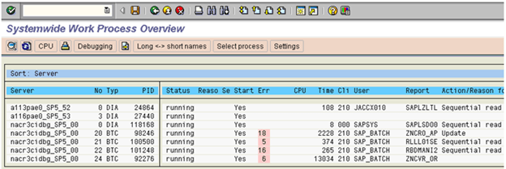](https://www.guru99.com/images/sap/2013/05/050913_0552_4.png)

By checking the work process load using the global work process overview, we can quickly investigate the potential cause of a system performance problem.  
  
Monitor the work process load on all active instances **across the system**  
  
Using the *Global Work Process Overview*screen, we can see at a glance:

* The status of each application server
* The reason why it is not running
* Whether it has been restarted
* The CPU and request run time
* The user who has logged on and the client that they logged on to
* The report that is running

**Monitor Application User (AL08 and SM04)**

This transaction displays all the users of active instances.

[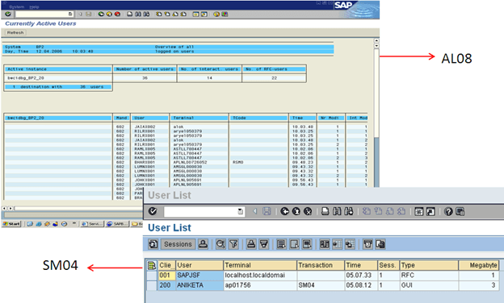](https://www.guru99.com/images/sap/2013/05/050913_0552_5.png)

**Monitoring Update Processes (SM13)**

Execute Transaction SM13 and put '**\***' in the field USER and click on [SAP Monitoring & Performance Checks: Complete Tutorial with Tcodes](https://www.guru99.com/images/sap/2013/05/050913_0552_6.png) button.

[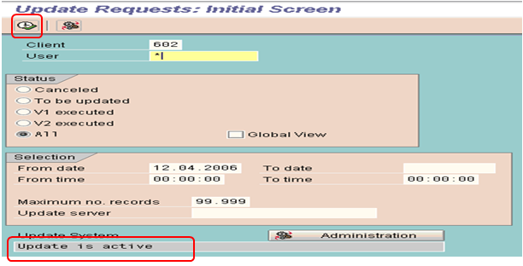](https://www.guru99.com/images/sap/2013/05/050913_0552_7.png)

If there are no long pending updates records or no updates are going on then this queue will be empty as shown in the below screen shot.

[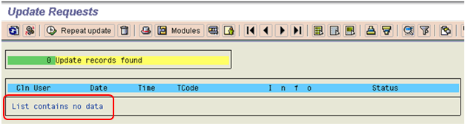](https://www.guru99.com/images/sap/2013/05/050913_0552_8.png)

But, if the Update is not active then find the below information:

* Is the update active, if not, was it deactivated by the system or by a user?
  + Click on [SAP Monitoring & Performance Checks: Complete Tutorial with Tcodes](https://www.guru99.com/images/sap/2013/05/050913_0552_9.png) button and get the information.
  + Click on [SAP Monitoring & Performance Checks: Complete Tutorial with Tcodes](https://www.guru99.com/images/sap/2013/05/050913_0552_10.png) button and get the below information:
* Is any update cancelled?
* Is there a long queue of pending updates older than 10 minutes?

**Monitoring Lock Entries (SM12)**

Execute Transaction SM12 and put '*' in the field User Name

[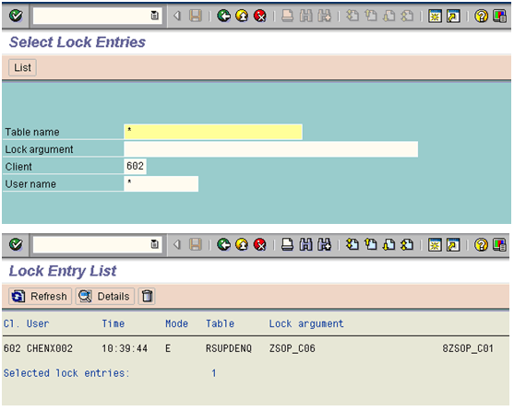](https://www.guru99.com/images/sap/2013/05/050913_0552_11.png)

SAP provides a *locking mechanism* to prevent other users from changing the record that you are working on. In some situations, locks are not released. This could happen if the users are cut off i.e. due to network problem before they are able to release the lock.  
  
These old locks need to be cleared or it could prevent access or changes to the records.  
  
We can use lock statistics to monitor the locks that are set in the system. We record only those lock entries which are having date time stamp of the previous day.

X`  
 This transaction code will be useful to view all the sap locks that are present in the system. As part of monitoring, we need to look for any old sap locks that are more than 1 day. If any such locks, we need to analyse the reason for that lock for such longer duration and take actions accordingly. A lock can be set for such a long duration due to a long running background job or a lock is not released due to an application error or a program terminated abruptly but lock not released etc.

**Monitoring System Log (SM21)**

We can use the log to pinpoint and rectify errors occurring in the system and its environment.  
We check the log for the previous day with the following selection/option:

* Enter Date and time.
* Select Radio Button Problems and Warnings
* Press Reread System Log.

[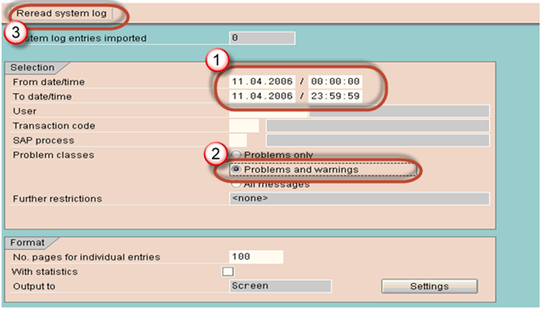](https://www.guru99.com/images/sap/2013/05/050913_0552_12.png)

This transaction is useful to view the log of the sap system for various operations. This log will be very useful to identify various issue in advance and to take necessary measures. System log is the place to check out for any timeout, network issues, database space issues, message server issues, spool overflow, locktable overflow etc issues.

**Tune Summary (ST02)**

This transaction will be used to monitor

* Buffer statistics like hitratio, swaps, db access details, size of buffer and free size of buffer etc
* Important statistics related to  Roll area, Page area, Extended memory and heap memory
* Call statistics like select, insert, update and delete

As a basis administrator, it is our responsibility to ensure there is more hit ratio for the buffers and less swaps to ensure efficient performance of the sap system. In case you see there are more swaps and less hit ratios for most of the buffers, then tuning buffers to be carried out to ensure optimal performance.

**Step 1:** Go to ST02 to check the Tune summary.  
  
**Step 2:** If you see any red values, in SWAPS, double –click the same.

[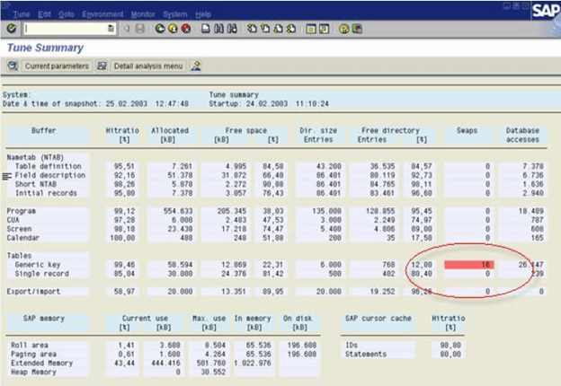](https://www.guru99.com/images/sap/2013/05/050913_0552_13.png)

**Step 3:** In the below screen click on the tab '*Current Parameters*'

[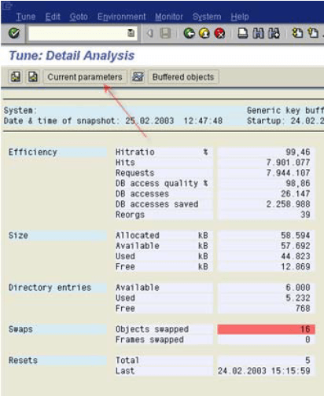](https://www.guru99.com/images/sap/2013/05/050913_0552_14.png)

**Step 4:** Note down the *value* and the *Profile parameters*

[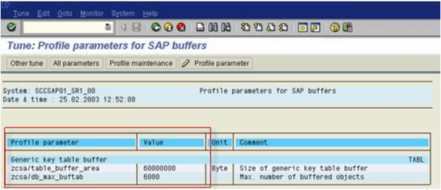](https://www.guru99.com/images/sap/2013/05/050913_0552_15.png)

**Step 5:** Go to RZ10 (to change the Profile parameter values)  
  
**Step 6:** Save the changes.  
  
**Step 7:** Restart the server to take the new changes effect.

**CPU Utilization (ST06)**

[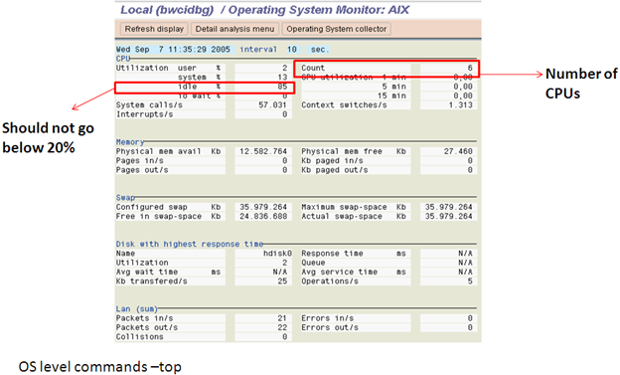](https://www.guru99.com/images/sap/2013/05/050913_0552_16.png)

Idle CPU utilization rate must be 60-65%, if it exceeds the value then we must start checking at least below things:

* Run OS level commands – top and check which processes are taking most resources.
* Go to SM50 or SM66. Check for any long running jobs or any long update queries being run.
* Go to SM12 and check lock entries
* Go to SM13 and check Update active status.
* Check for the errors in SM21.

**ABAP Dumps (ST22)**

Here we check for previous day's dumps.

This transaction code will be useful to view all the abap dumps that have occured in the system on a given day. As part of daily monitoring, it is the responsibility of the basis administrator to analyse the dumps and take necessary actions to avoid issues.

Some of the examples of abap dumps are timeout issue, database space issue, spool overflow issue etc

[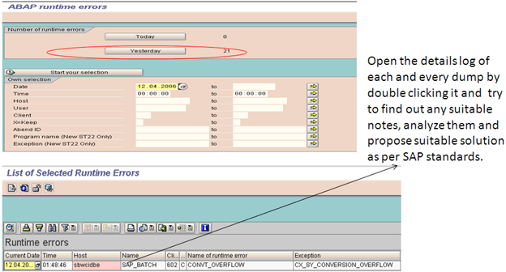](https://www.guru99.com/images/sap/2013/05/050913_0552_17.png)

**Spool Request Monitoring (SP01)**

For spool request monitoring, execute SP01 and select as below:

* Put '*' in the field *Created By*
* Click on [SAP Monitoring & Performance Checks: Complete Tutorial with Tcodes](https://www.guru99.com/images/sap/2013/05/050913_0552_18.png) execute button.

[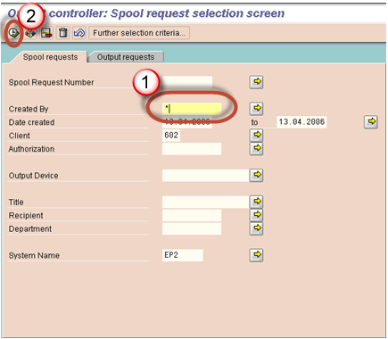](https://www.guru99.com/images/sap/2013/05/050913_0552_19.png)

Here we record only those requests which are terminated with problems.

[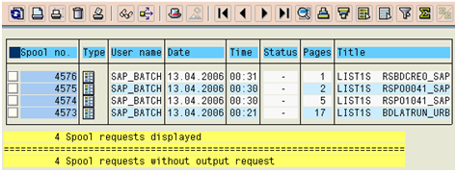](https://www.guru99.com/images/sap/2013/05/050913_0552_20.png)

This transaction is useful to find out the status of spool request and output request. In SP01 transcation, you can list the spool requests or output requests between a given interval.

In the list generated, you can check out the status of spool requests and findout any errors by drilling down further.

For eg: if so many spools are in waiting status, find out whether output device is available or not.

If many spool are in error status, figure out if there is any network issue and take necessary actions.

If  customers complain that they are not able print anything from SAP, check out whether there is any spool overflow.

**Monitoring Batch Jobs (SM37)**

This transaction will be useful to have an overview of jobs with different statuses.

As part of daily monitoring, SAP basis administrator should use this transaction to findout canceled jobs and active jobs(for eg: long running - more than 24hrs etc).

Incase of canceled jobs, root cause for the failure to be figured out from the logs of the respective job and to be actioned by rescheduling etc.

Incase of long running jobs, we need to figure out the reason for long running and action them accordingly.

In SM37, using extended job selection option, we can even select the jobs based on start condition, steps (like abap program, external command or external program), period etc

For Monitoring background jobs, execute SM37 and select as below:

* Put '*' in the field *User Name*and*Job name*
* In Job status, select: Scheduled, Cancelled, Released and Finished requests.

[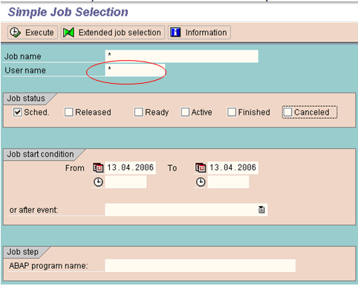](https://www.guru99.com/images/sap/2013/05/050913_0552_21.png)

**Transactional RFC Administration (SM58)**

Transactional RFC (tRFC, also originally known as asynchronous RFC) is an asynchronous communication method which executes the called function module in the RFC server only once.

[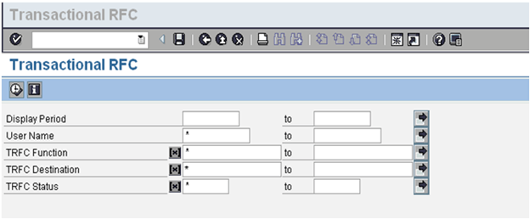](https://www.guru99.com/images/sap/2013/05/050913_0552_22.png)

We need to select the display period for which we want to view the tRFCs and then select '*' in the username field to view all the calls which have not be executed correctly or waiting in the queue.

**QRFC Administration (*Outbound Queue*-SMQ1)**

We should specify the client name over here and see if there any outgoing qRFCs in waiting or error state.

[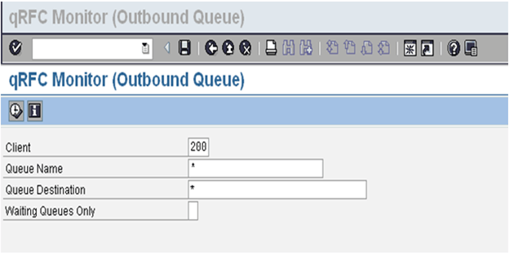](https://www.guru99.com/images/sap/2013/05/050913_0552_23.png)

**QRFC Administration (*Inbound Queue*-SMQ2)**

[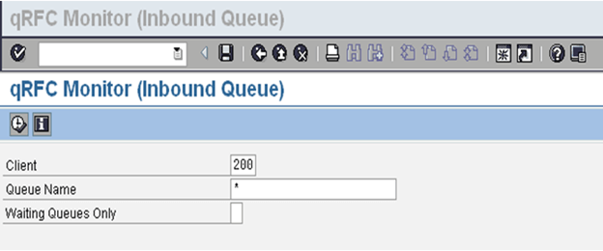](https://www.guru99.com/images/sap/2013/05/050913_0552_24.png)

We should specify the client name over here and see if there any incoming qRFCs in waiting or error state.

**Database Administration (DB02)**

[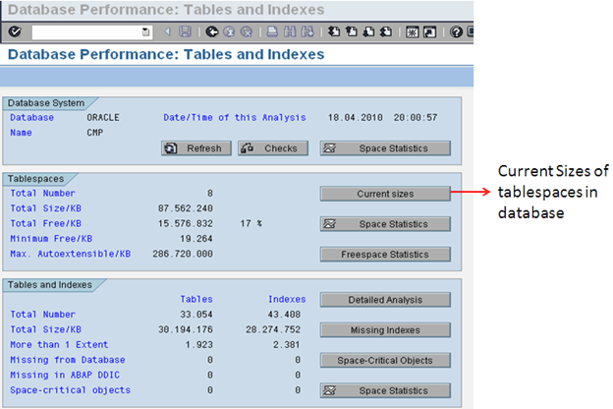](https://www.guru99.com/images/sap/2013/05/050913_0552_25.png)

After you select **Current Sizes**on the first screen we come to the below screen which shows us the current status of all the tablespaces in the system.

[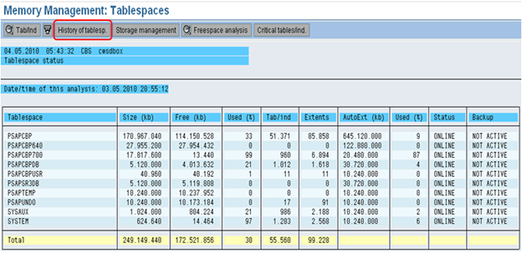](https://www.guru99.com/images/sap/2013/05/050913_0552_26.png)

If any of the tablespaces is more than 95% and the auto extent is off then we need to add a new datafile so that the database is not full.  
We can also determine the history of tablespaces.

[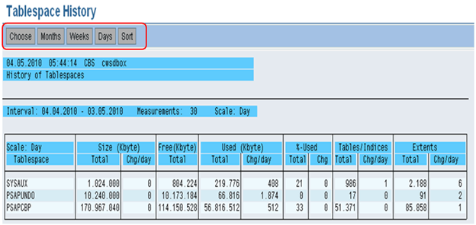](https://www.guru99.com/images/sap/2013/05/050913_0552_27.png)

We can select Months, Weeks or Days over here to see the changes which take place in a tablespace.  
We can determine the growth of tablespace by analyzing these values.  
 [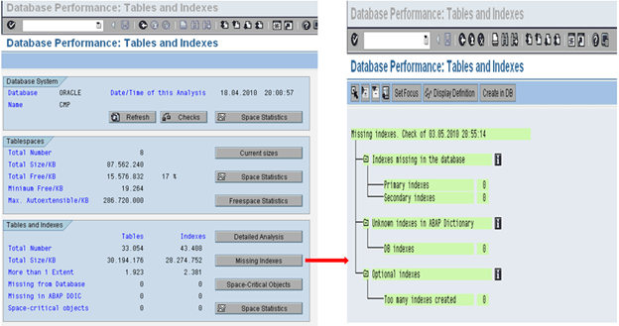](https://www.guru99.com/images/sap/2013/05/050913_0552_28.png)

[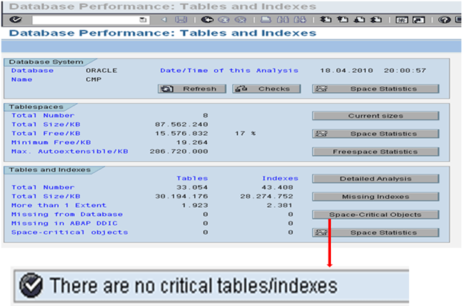](https://www.guru99.com/images/sap/2013/05/050913_0552_29.png)

**Database Backup logs (DB12)**

From this transaction, we could determine when the last successful backup of the system was. We can review the previous day's backups and see if everything was fine or not.  
  
We can also review the redo log files and see whether redo log backup was successful or not.

[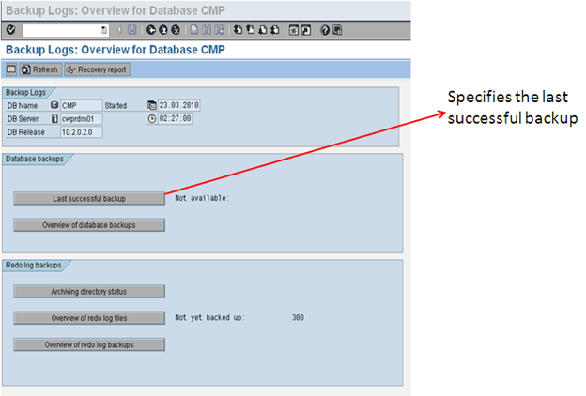](https://www.guru99.com/images/sap/2013/05/050913_0552_30.png)

**SXI_Cache** : This Tcode is specific to XI or PI system. This Tcode is used to findout whether cache refresh is happening or not. Incase if cache refresh is happening successfully, it will indicate the same in green color. Otherwise it will be in red indicating a problem with cache refresh.

If there is a problem with cache refresh then basis administrator has to troubleshoot the same.

**SLDCHECK :** This Tcode will be useful to figure out whether connection to the SLD system from the system on which you are testing is fine or not. In case the connection is fine, all checks will appear in green. Incase of any issues, it will appear in red or yellow and then basis administator has to troubleshoot it and make sure SLDCHECK is working fine.

Ensuring SLDCHECK is working fine is important to keep all systems in the landscape in sync.

**SXI_MONITOR :** This TCode is specific to XI or PI system. This transaction will be useful to figure out any errors or warnings in the processing of XI or PI messages. In case of any issues, this needs to be informed to functional team and should be troubleshooted accordingly with the functional team inputs.

**Quick Review**

Daily Monitoring Tasks

1. Critical tasks
2. SAP System
3. Database

**Critical tasks**

| **No** | **Task** | **Transaction** | **Procedure / Remark** |
| --- | --- | --- | --- |
| 1 | Check that the R/3System is up. |  | Log onto the R/3 System |
| 2 | Check that daily backup executed without errors | DB12 | Check database backup. |

**SAP System**

| **No** | **Task** | **Transaction** | **Procedure / Remark** |
| --- | --- | --- | --- |
| 1 | Check that all application servers are up. | SM51 | Check that all servers are up. |
| 2 | Check work processes (started from SM51). | SM50 | All work processes with a “running” or a “waiting” status |
| 3 | Global Work Process overview | SM66 | Check no work process is running more than 1800 second |
| 3 | Look for any failed updates (update terminates). | SM13 | * Set date to one day ago * Enter * in the user ID * Set to “all” updates Check for lines with “Err.” |
| 4 | Check system log. | SM21 | Set date and time to before the last log review. Check for:   * Errors * Warnings * Security messages * Database problems |
| 5 | Review for canceled jobs. | SM37 | Enter an asterisk (*) in User ID.Verify that all critical jobs were successful. |
| 6 | Check for “old” locks. | SM12 | Enter an asterisk (*) for the user ID. |
| 7 | Check for users on the system. | SM04AL08 | Review for an unknown or different user ID and terminal.This task should be done several times a day. |
| 8 | Check for spool problems. | SP01 | Enter an asterisk (*) for Created ByLook for spool jobs that have been “In process” for over an hour. |
| 9 | Check job log | SM37 | Check for:   * New jobs * Incorrect jobs |
| 10 | Review and resolve dumps. | ST22 | Look for an excessive number of dumps. Look for dumps of an unusual nature. |
| 11 | Review buffer statistics. | ST02 | Look for swaps. |

**Database**

| **No** | **Task** | **Transaction** | **Procedure /  Remark** |
| --- | --- | --- | --- |
| 1 | Review error log for problems. | ST04 |  |
| 2 | Database GrowthMissing Indexes | DB02 | If tablespace is used more than 90 % add new data file to itRebuild the Missing Indexes |
| 3 | Database Statistics log | DB13 |  |

|  |
| --- |
| **Os level checks** |
| 1 | Check filesystems usage (shouldb be <80%) |
| 2 | Check for swap space using topas etc |
| 3 | Check for work directory log files at oslevel for errors |